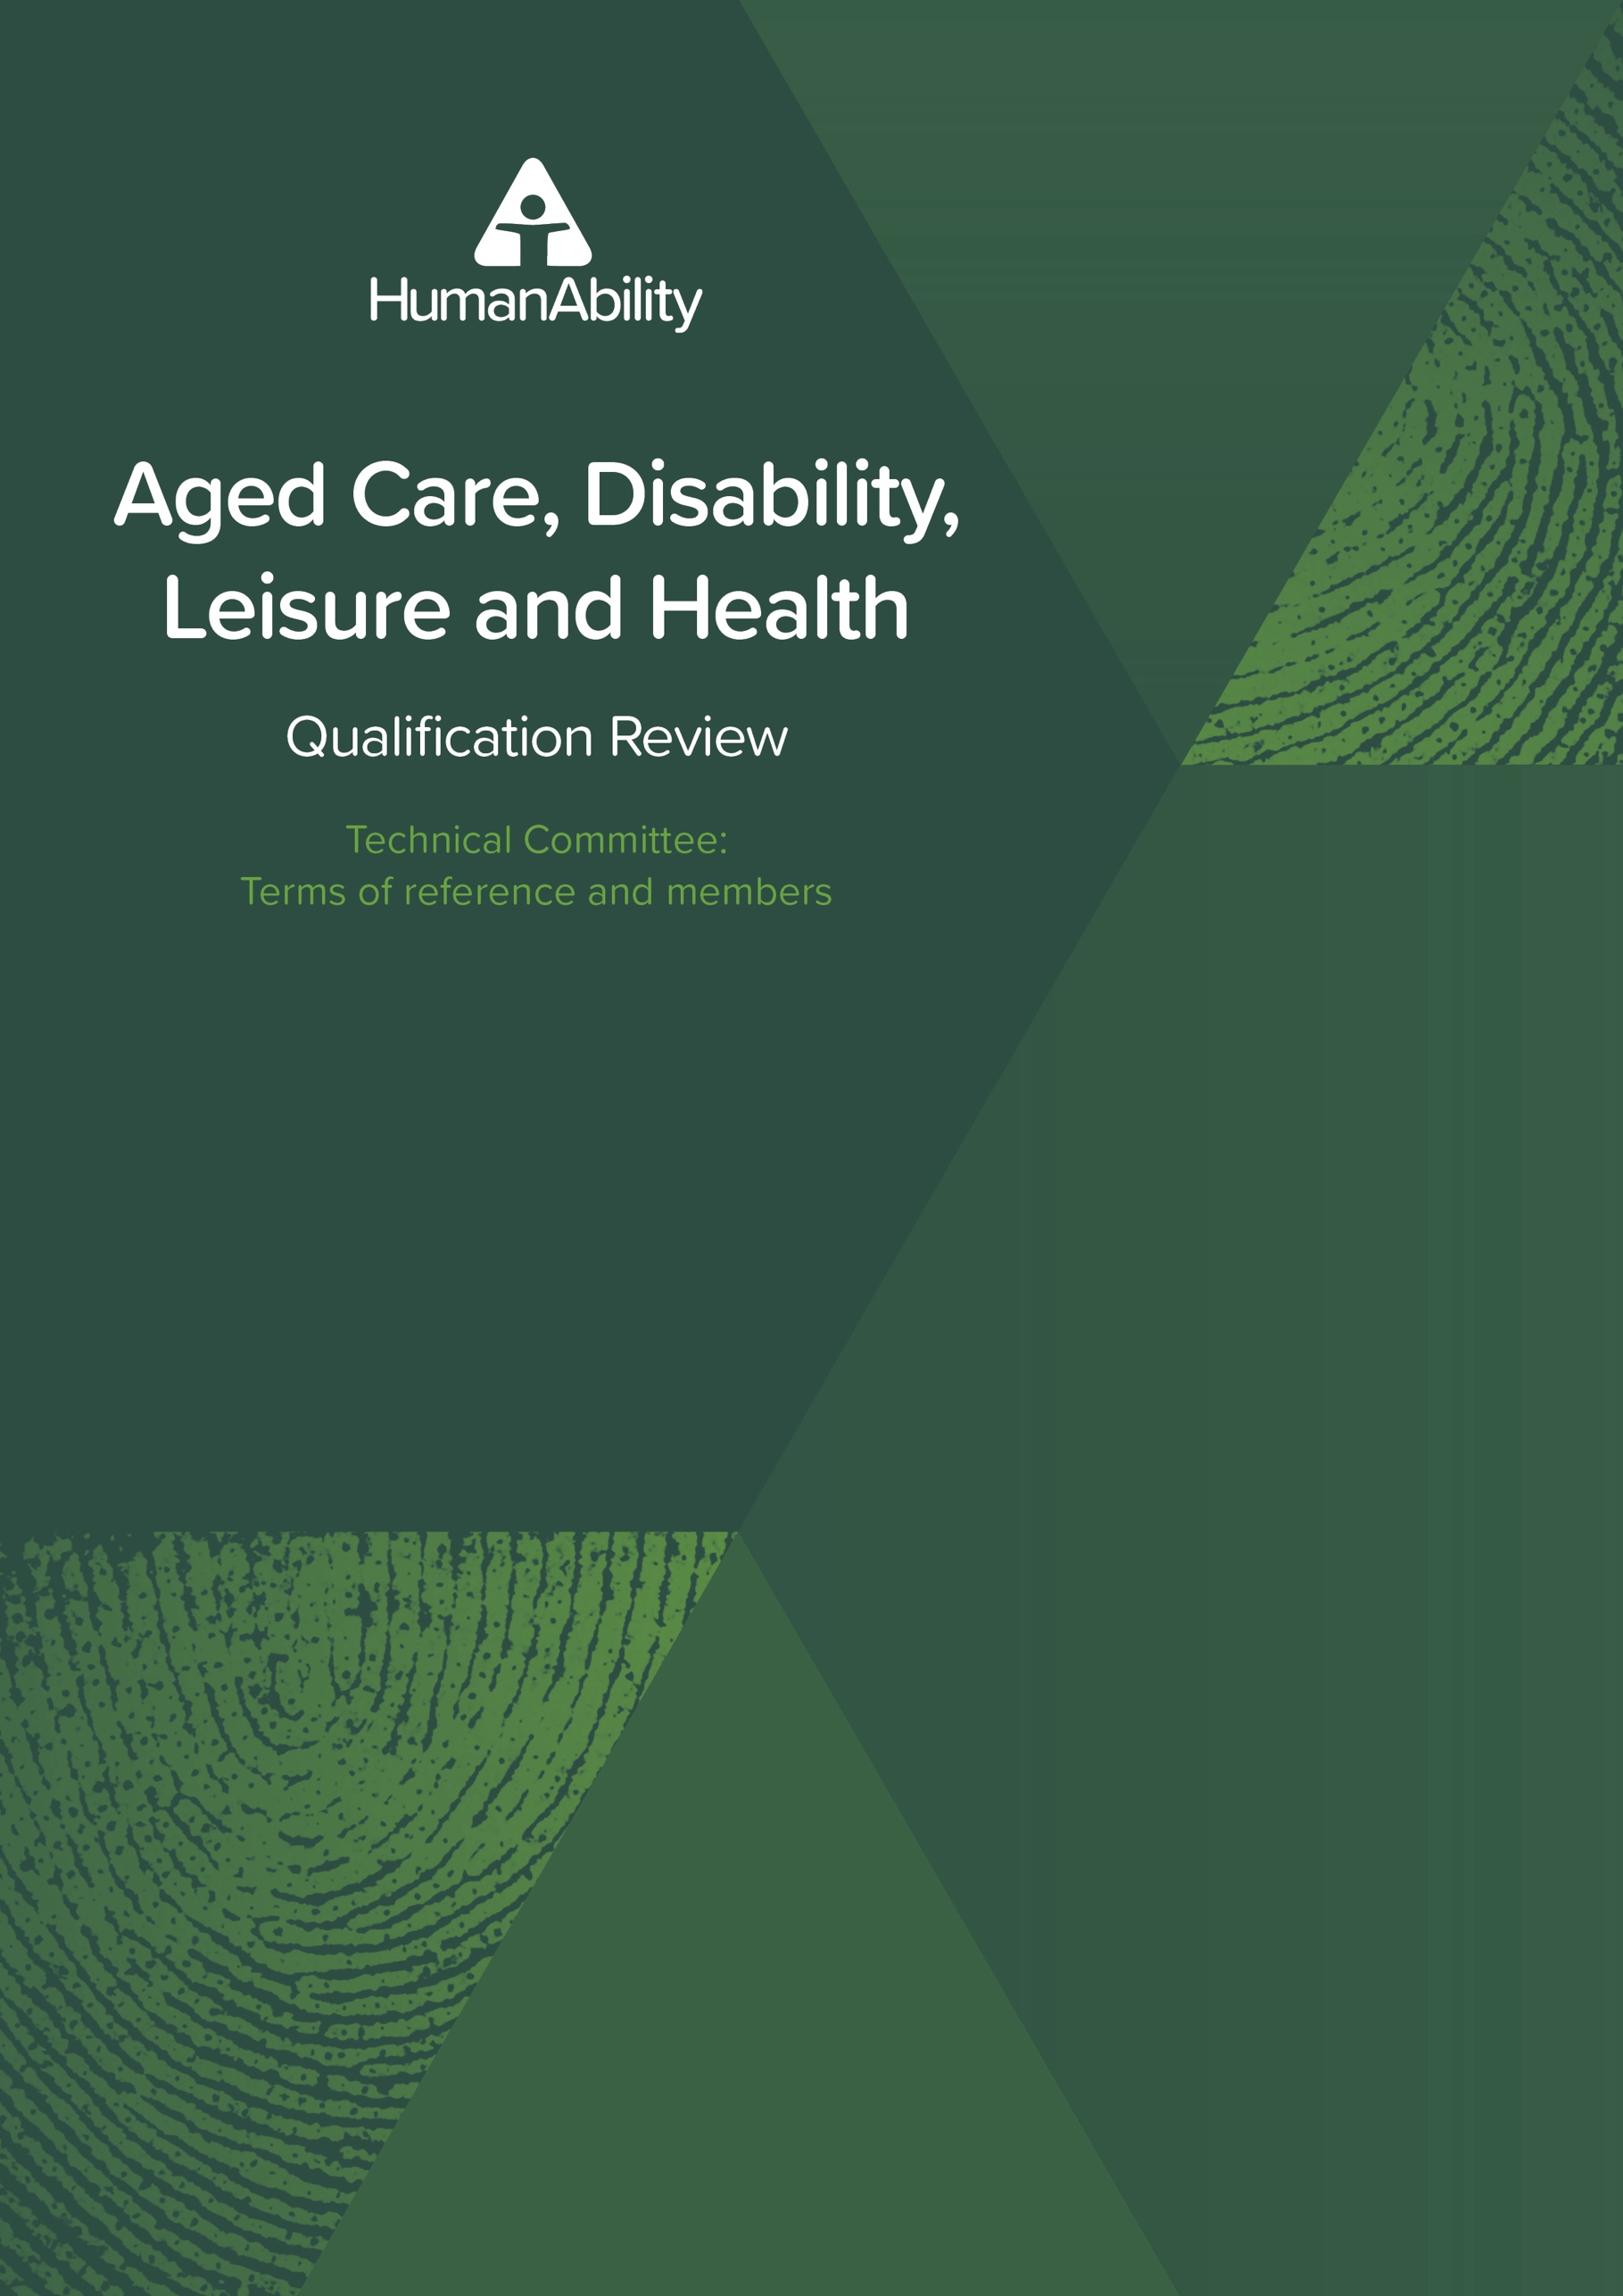

Table of Contents

Document Modification History 3

1.Background and purpose 3

2Role of the Committee 3

3.Function and Appointment of Membership 4

4.Scope and Duration 4

5.Decision-making 5

6.Conflict of Interest 5

7.Privacy and Confidentiality 5

8.Training Package Organising Framework 6

9.Fees and Costs 6

10.Technical Committee Members 6

Document Modification History

|  |  |  |  |
| --- | --- | --- | --- |
| Version | Status | Release date | Summary of changes |
| V1 | Current | 30th June 2025 | Document published |

1. Background and purpose
2. Technical Committees are required to be established by HumanAbility, as a Jobs and Skills Council (JSC) for each training product project undertaken by HumanAbility.
3. Technical Committees advise HumanAbility on training product design, development, delivery, assessment, and consultation strategy.
4. Members of the Technical Committee are appointed by the CEO of HumanAbility based on their individual expertise and ensuring the committee membership reflects HumanAbility’s commitment to a tripartite governance model.
5. Technical Committees are guided by the training package product development rules, set out in the Training Package Organising Framework (see section eight (8) for more detail).
6. The Training Package Organising Framework sets out the rules and requirements for the development and content of nationally endorsed training packages.
7. These Terms of Reference relate to the Aged Care, Disability, Leisure and Health qualification review (see section four (4) for more detail on the scope and duration of this project).
8. Role of the Committee
9. The role of the Technical Committee is to draw on their expertise to advise HumanAbility on training design, delivery and assessment, AQF levels, impacts on learners, possible implementation issues, and identify any additional stakeholders that should be included in the consultation strategy.
10. The role of the Technical Committee is exclusively related to training product development.
11. The role of members of the committee will be to draw on their experience and expertise, not to represent their organisation (organisational representatives will be consulted outside of Technical Committees).
12. Members should genuinely contribute to discussion and respect the viewpoints of others and the right for them to express their views.
13. The expectation is that the committee will meet online approximately three to four times during the project and will also need to be available to review materials and provide timely feedback. Timely is defined as responding within five (5) working days for an average project. Where there is a larger project, this will be stipulated when a response is requested, and a timely response would be within ten (10) working days.
14. Input might be sought through email and collaboration tools in place of meetings.
15. Function and Appointment of Membership
16. The Technical Committee will comprise no less than eight (8) and no more than eighteen (18) individuals. The composition will vary based on the level of complexity and breadth of the project.
17. The Technical Committee must be tripartite with membership from union, government and employers.
18. Membership must include individuals with the technical / specialist and/or industry sector knowledge to be able to contribute to the package development.
19. Members are appointed based on their expertise and experience, not as representatives of their organisation. If a member is unable to attend a meeting, they are unable to appoint a proxy.
20. To maintain HumanAbility’s commitment to broad engagement and inclusivity, wherever possible members of a Technical Committee will not also be a member of a HumanAbility Industry Advisory Committee.
21. The spread of Technical Committee membership will reflect geographical and other distributional representation to the extent possible for each project and context.
22. Following a request for nominations, HumanAbility will determine a proposed committee reflecting the criteria set out in this section.
23. HumanAbility’s CEO has final approval of Technical Committee membership. Following approval, HumanAbility will then invite approved nominees to become members of the Technical Committee.
24. Members of the Committee must read and agree to adhere to the [Jobs and Skills Council Code of Conduct](https://www.dewr.gov.au/skills-reform/resources/jobs-and-skills-councils-code-conduct).
25. Secretariat services are provided by HumanAbility staff.
26. Observers may be invited to a Technical Committee meeting to foster collaboration or knowledge sharing on critical issues. Observers do not have voting rights nor decision-making authority and must adhere to the rules of conduct set out in the Terms of Reference. Observer status is for the specific meeting specified in the invitation. HumanAbility may extend or revoke observer status based on Members’ feedback on the value of the observer participation.
27. The Department of Employment and Workplace Relations may attend a committee meeting at any time.
28. Scope and Duration
29. The Scope of the Technical Committee is limited to advice as it pertains to the project/s listed in 4.1.1. The project scope includes research, consultation, development work and implementation support in relation to: Aged Care, Disability, Leisure and Health qualification review
30. Reviewing the CHC33021 Certificate III in Individual Support, CHC43121 Certificate IV in Disability Support, CHC43015 Certificate IV in Ageing Support, CHC43415 Certificate IV in Leisure and Health, CHC53415 Diploma of Leisure and Health and 11076NAT Diploma of Leadership in Disability Services qualifications.
31. The duration of the committee is limited to the duration of the project. The project is due to be completed in November 2026.
32. Decision-making
33. A Technical Committee will be established for each training product review project.
34. The Technical Committee will be overseen by HumanAbility CEO via the Director, Training Product Development (Director).
35. The Director will provide progress reports and recommendations to the CEO at key points in the project, where the CEO will decide how to proceed, considering all advice received from the members of the Technical Committee. These reports and updates will include advice and supporting rationale from the Technical Committee to assist the CEO’s decision-making.
36. The HumanAbility Board will be provided periodic updates on the advice provided by the Technical Committee and project progress through the standard CEO reports to the Board.
37. As the Technical Committee is not a decision-making body, if members of the Technical Committee hold divergent views, the range of opinions and rationales will be provided to the CEO for consideration alongside stakeholder feedback received throughout the project, for example from consultation activities.
38. A statement that the Technical Committee has provided advice and reviewed the draft training products will form part of the submission to the Assurance Body.
39. Conflict of Interest
40. Committee members are required to disclose any actual, potential, or perceived conflicts of interest in relation to the training package project under review.
41. A perceived or actual conflict of interest will not exclude a person from membership of the Committee but must be declared for transparency and appropriate management as per the JSC Code of Conduct.
42. Privacy and Confidentiality
43. The name, organisation, job title and stakeholder category of Technical Committee members will be published on the HumanAbility website.
44. Stakeholder contributions made through the broader consultation on this project will be captured in the Consultation Log which will also be published on the website.
45. Where virtual meetings are held, these will be recorded to assist with record keeping.
46. All Committee Members are required to maintain strict confidentiality regarding any time-sensitive, commercial-in-confidence or restricted information discussed or shared during Committee activities and meetings.
47. Training Package Organising Framework
48. The Training Package Organising Framework (TPOF) outlines the product and process requirements for the development and endorsement of all national training package products in Australia.

These guidelines, known as the Training Package Organising Framework (TPOF), establish a new, purpose-driven approach to designing qualifications.

The TPOF outlines:

* Product Requirements – defining the overarching principles for designing and developing training package products that are submitted for endorsement by Skills Ministers. It also specifies the design rules that must be followed when creating or updating a training package product.
* Process Requirements – detailing the procedures for developing and obtaining endorsement for nationally recognised training package products.

Further details can be found on the Department of Employment and Workplace Relations website.

1. Fees and Costs
2. Technical Committee Members do not receive a sitting/meeting fee or reimbursement for their role on the committee. There will be remuneration for Lived Experience Members of the Committee, in line with the HumanAbility Lived Experience Payment Recognition Policy. The policy applies to individuals who are not representatives of an organisation, group, or council that already receives funding or remuneration for their participation.
3. Meetings will be held online so should not incur additional costs to the committee members.
4. Where any face-to-face meetings are arranged for the purpose of the technical committee only, this will be at the expense of HumanAbility.
5. Committee members will need to allocate time to review materials outside of meetings.

1. Technical Committee Members

Technical Committee membership may change throughout a project. This table shows nominated Technical Committee membership as at: **18 June 2025**.

|  |  |  |  |  |
| --- | --- | --- | --- | --- |
| **Name** | **Organisation** | **Title** | **State / Territory** | **Stakeholder Type** |
| Sheryl Boniface | National Workforce Collaboration, YPINHNA, SB & Associates Consultancy | Managing Director and Project Manager | SA | Other |
| Charlise Bennett | Australian Recreational Therapy Association | Executive Officer | NSW | Industry Association / Peak body |
| Kim Bromley | Homewood Care and Tafe NSW | Diversional / Recreational Therapist and TAFE Casual Teacher | NSW | Employee and RTO -educational expert |
| Maggie Rushton | Bestwest care | RTO Compliance Manager | WA | Vocational Education and Training |
| Michelle Devereux | Richmond Institute of Sport and Leadership | Education Coordinator (Leisure and Health) | VIC | RTO -educational expert |
| Lynda Flint | TasTAFE | Education Manager | TAS | RTO -educational expert |
| Andrew Hayward | Ageing Australia (previously ACCPA) | Head of Workforce Strategy | QLD | Industry Association / Peak body |
| Joanne Jones | The Gordon | Portfolio Manager Health & Human Services | VIC | RTO -educational expert |
| Lourdes Zamanillo | National Disability Services | Workforce Innovation lead | VIC | Industry Association / Peak body |
| Frances Sanders | Nightlife Disability Services | CEO | VIC | Employer or Enterprise |
| Kate Hurrell | Three Tree Lodge (residential aged care provider in rural NSW) | CEO | NSW | Employer or Enterprise (i.e. service provider) |
| Caroline Thompson | CSWA | Executive Director | WA | ITAB/ITAC |
| Gregory Burgess | Canberra Institute of Technology. | Teacher | ACT | RTO -educational expert |
| Zelda Riddell | HACSU/HSU delegate, working for Home@Scope/ Scope | Disability support worker and delegate | VIC | Union |
| Kylie Cakau | ANMEC - Australian Nursing & Midwifery Education Centre | Course Manager | SA | RTO -educational expert |